**AUTOMATIC TEMPERATURE CONTROLED FAN**

# introduction

This project is a standalone automatic fan controller that controls an electric fan according to our requirement. Use of embedded technology makes this closed loop feedback control system efficient and reliable. Microcontroller controls the fan. Liquid crystal display (LCD) makes the system user-friendly. The sensed temperature is displayed on the LCD panel. It is very compact using few components and can be implemented for several applications including meeting rooms, bedroom, ovens, heat-exchangers, incubators, thermal baths and veterinary operating tables. ARDUINO micro controller is the heart of the circuit as it controls all the functions. The temperature sensor LM35 senses the temperature and converts it into an electrical (analog) signal, which is applied to the microcontroller. The sensed and set values of the temperature are displayed on the 16x2-line LCD. This project is useful in process industries for maintenance and controlling of Boilers temperature and can fix the error of where the system is designed to be turned on manually by an operator, because sometimes operators are not around or they may have human error which can result in malfunction of equipment or people around in the room might feel uncomfortable.

## Parts of system

1. **ARDUINO UNO BOARD**

In the proposed systems, microcontroller plays a vital role in the smart systems development. Microcontrollers have become an essential part in the present technologies that are being presented daily. This article discusses temperature based fan speed control and monitoring system using an Arduino system.This system is used to control the cooling system automatically based on the room temperature.The system uses an Arduino board to implement a control system. Since this system is proposed to control the cooling system and it is very important to know Arduino controlled system well.

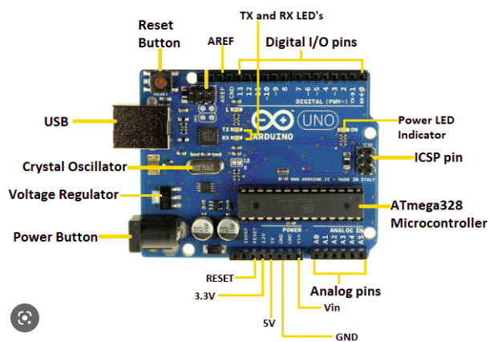

1. **TEMPERATURE SENSOR**

Temperature Sensor: We are using LM 35 as temperature sensor. LM 35 is a precision temperature sensor whose output is linearly proportional to Celsius Temperature. The LM35 is rated to operate from -55° Centigrade to 150° Centigrade with a linear scale factor of +10mv/° C

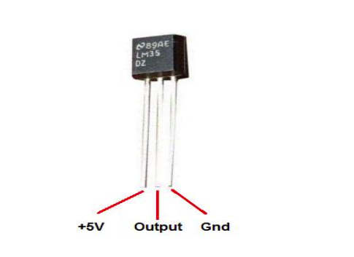

1. **Liquid Crystal Display**

The LCD is a dot matrix liquid crystal display that displays alphanumeric characters and symbols. 16X2 LCD digital display has been used in the system to show the room temperature. Liquid Crystal Display screen is an electronic display module and find a wide range of applications. A 16x2 LCD display is very basic module and is very commonly used in various devices and circuits. These modules are preferred over sevensegments and other multi segment LEDs. The reasons being: LCDs are economical; easily programmable; have no limitation of displaying special & evencustom characters (unlike in seven segments), animations and so on. A 16x2 LCD means it can display 16 characters per line and there are 2 such lines. In this LCD each character is displayed in 5x7 pixel matrix. This LCD has two registers, namely, Command and Data.The command register stores the command instructions given to the LCD. A command is an instruction given to LCD to do a predefined task like initializing it, clearing its screen, setting the cursor position, controlling display etc. The data register stores the data to be displayed on the LCD. The data is the ASCII value of the character to be displayed on the LCD.

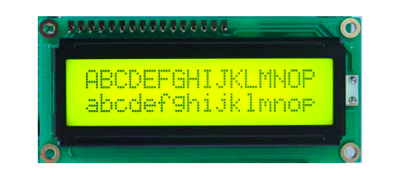

1. **ELECTRIC FAN**

A fan is a powered machine used to create a flow of air. A fan consists of a rotating arrangement of vanes or blades, generally made of wood, plastic, or metal, which act on the air.

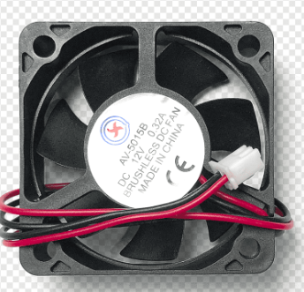

**5 ARDUINO IDE**

Arduino IDE is **an open-source software, designed by Arduino.cc** and mainly used for writing, compiling & uploading code to almost all Arduino

**Codes used in our circuit:**

*#include <Wire.h>*

*#include <LiquidCrystal_I2C.h>*

*//i2c pins*

*LiquidCrystal_I2C lcd(0x27, 16, 2);*

*int temp = A0; // the output pin of TMP36*

*int tempin;*

*int cel;*

*int tempmin = 19;*

*int relay = 7;*

*void setup() {*

*lcd.begin(16,2);*

*lcd.backlight();//Power on the back light*

*//lcd.backlight(); Power off the back light*

*pinMode(temp, INPUT);*

*pinMode(relay, OUTPUT);*

*}*

*void loop() {*

*temp = analogRead(temp);*

*cel = temp * 0.48828125;*

*Serial.print(cel);*

*Serial.println();*

*if (temp > tempin) {*

*lcd.clear();*

*lcd.setCursor(0, 1);// move cursor to next line*

*lcd.print("Fan STATUS:");*

*lcd.print("ON"); // display the temperature*

*digitalWrite(relay, HIGH);*

*delay(3000);*

*}*

*else {*

*lcd.clear();*

*lcd.setCursor(0, 1);// move cursor to next line*

*lcd.print("Fan STATUS:");*

*lcd.print("OFF"); // display the temperature*

*digitalWrite(relay, LOW);*

*delay(3000);*

*}*

*lcd.clear();*

*lcd.setCursor(0, 0);*

*lcd.print("Temperature:");*

*lcd.print(cel); // display the temperature*

*lcd.print("C ");*

*delay(2000);*

*lcd.clear();*

*}*